All Item

**Weapon Box**

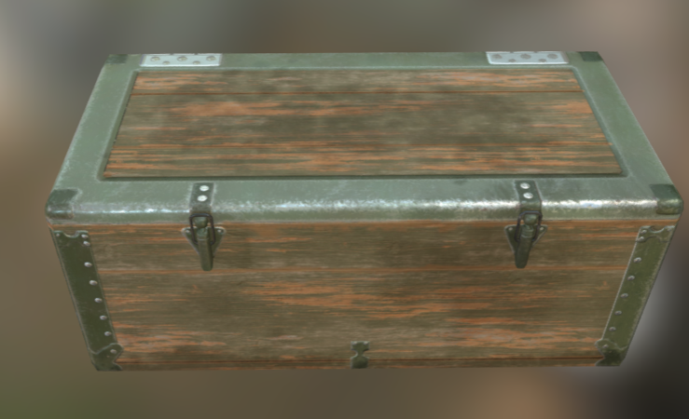

Link: [Weapon Box | 3D 道具 | Unity Asset Store](https://assetstore.unity.com/packages/3d/props/weapon-box-63084)

Operation: Open with the left click, it will be destroyed in the scene

Use: Get a random weapon for this stage

**Item Box**

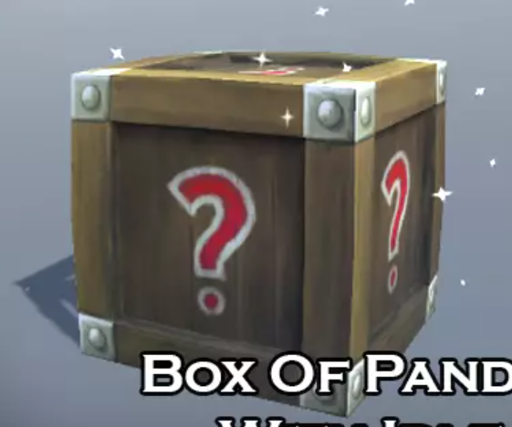

Link: [Potions, Coin And Box of Pandora Pack | 3D 道具 | Unity Asset Store](https://assetstore.unity.com/packages/3d/props/potions-coin-and-box-of-pandora-pack-71778#content)

Operation: Open with the left click, it will be destroyed in the scene

Use: Get a random item for this stage

**Health Potion**

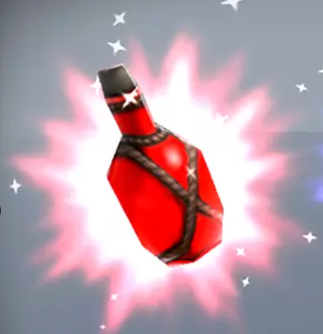

Link: [Potions, Coin And Box of Pandora Pack | 3D 道具 | Unity Asset Store](https://assetstore.unity.com/packages/3d/props/potions-coin-and-box-of-pandora-pack-71778#content)

Operation: use with the left click, Amount -1

Use: Restore health

**Speed Potion**

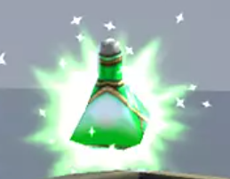

Link: [Potions, Coin And Box of Pandora Pack | 3D 道具 | Unity Asset Store](https://assetstore.unity.com/packages/3d/props/potions-coin-and-box-of-pandora-pack-71778#content)

Operation: use with the left click, Amount -1

Use: Increase move speed

**Jumping Potion**

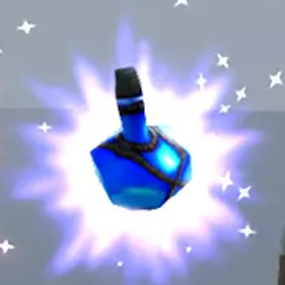

Link: [Potions, Coin And Box of Pandora Pack | 3D 道具 | Unity Asset Store](https://assetstore.unity.com/packages/3d/props/potions-coin-and-box-of-pandora-pack-71778#content)

Operation: use with the left click, Amount -1

Use: Increase jump height

**Gate key1 && Gate key2**

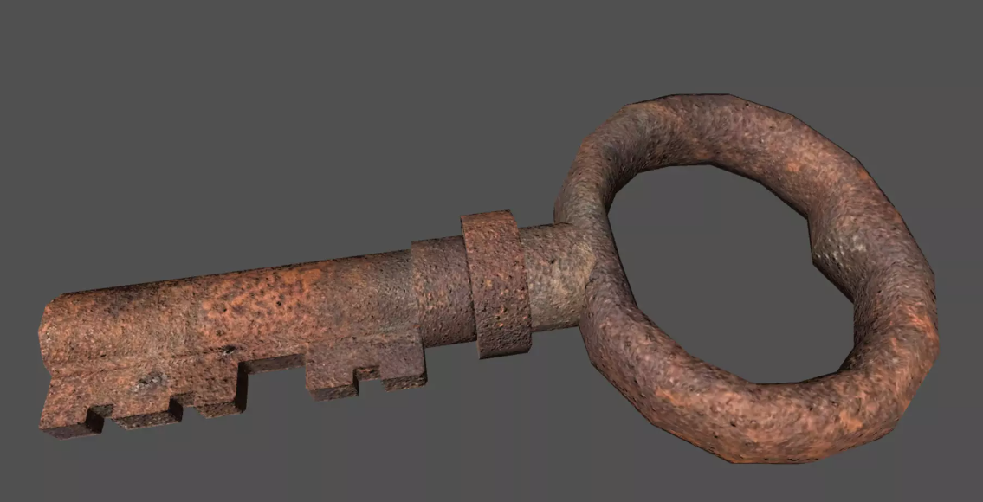

Link: [Rust Key | 3D 道具 | Unity Asset Store](https://assetstore.unity.com/packages/3d/props/rust-key-167590#reviews)

Operation: use with the left click, Amount -1

Use: Open the first stage’s gate, can be find in item box or guard

**Timer**

Operation: use with the left click, Amount -1

Use: add 30s to the remaining time